COMP421 Database Systems Project 3
Group 27
Zhong Guan 260758587
Runze Zhang
Yining Zhou 260706795
- Stored Procedure
The stored procedure we designed is to compute the average amount of a brand in the product table and then use this value to modify the quantity of a product in save_to_shopping_cart table. Both brand and product to be modified are all input provided by user.
Besides the stored procedure, we also created a trigger associated with this procedure. Whenever the quantity of a product in the save_to_shopping_cart table changes, we will log it into a separate table named shoppingcart_audits through this trigger.
The stored procedure is as follows:
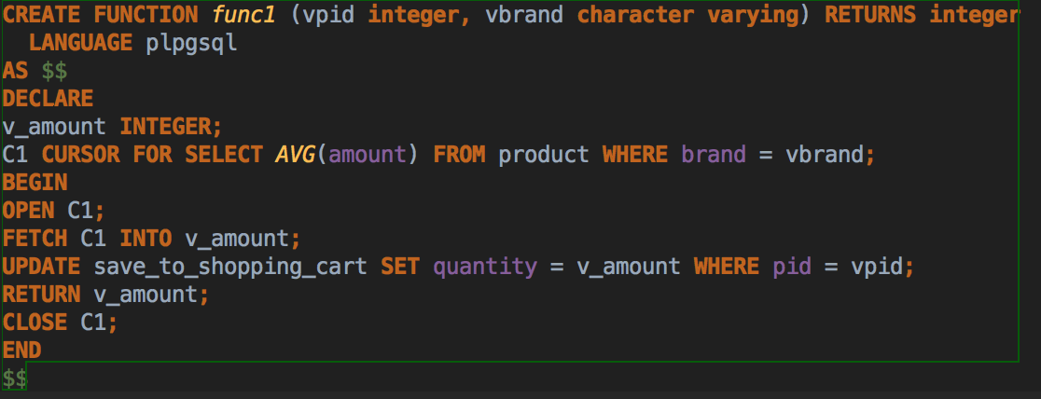
When we execute the function by , it will return the average amount of product of bran Microsoft in the shopping cart: 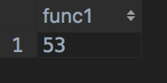
If we query the relation save_to_shopping_cart by using before and after the stored procedure was executed, we can see its difference.

Before
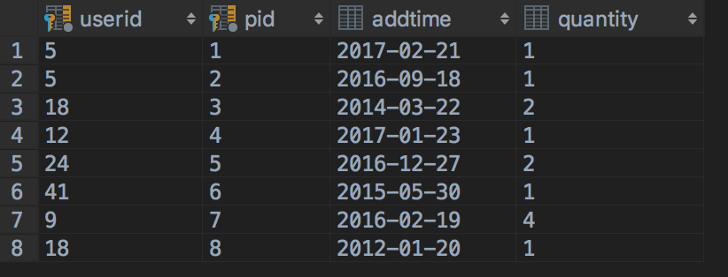
After
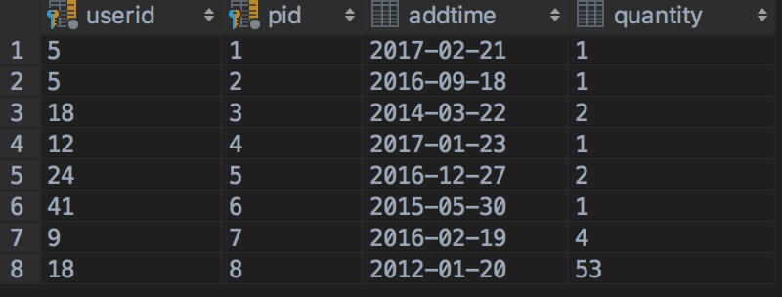
Before we define the trigger function, we created a table named shoppingcart_audits to store the changes.
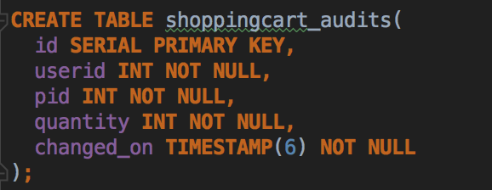
The trigger function is as follows:
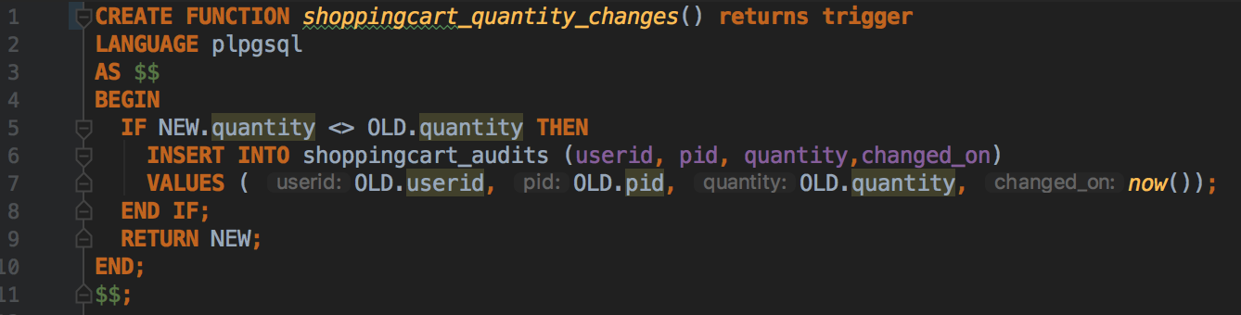
The function checks if the quantity of product in the shopping cart changes, it will insert the old quantity into the shoppingcart_audits that including userid, pid and the time of change.
Second, we bind the trigger function to the save_to_shopping_cart table. The trigger name is quantity_changes. Before the value of the quantity column is updated, the trigger function is automatically invoked into log the changes.
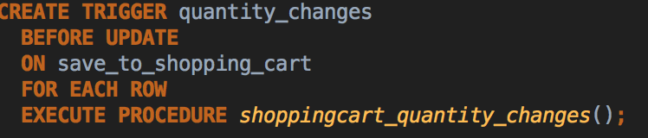
Third, we can use the stored procedure for test.
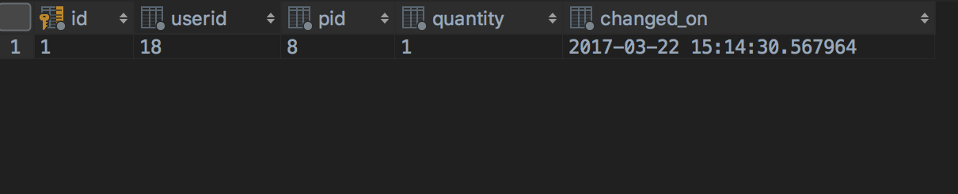
Then, we update the quantity again, the result indicates the trigger function works successfully.
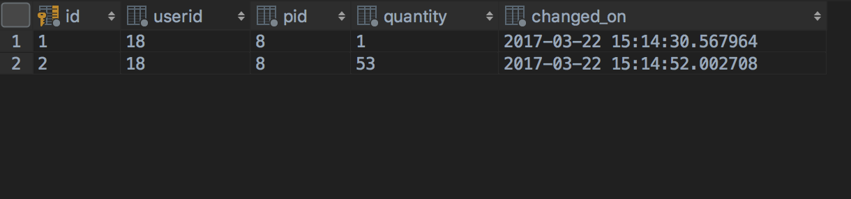
- Create index
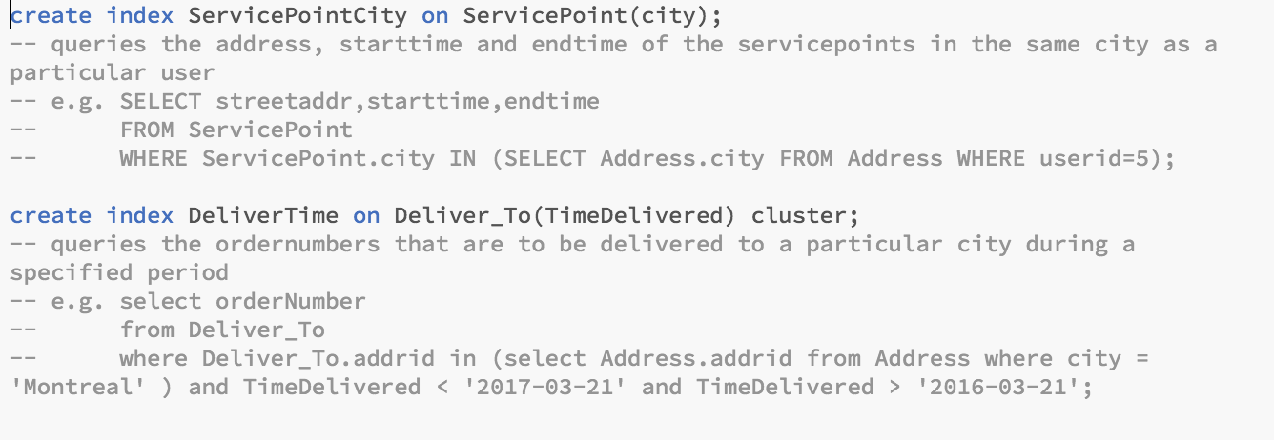
(p.s.) The comments in the above picture shows what queries would execute quicker.
The index can be created on attributes that are frequently queried in the sub-query, such as the attributes in the “where” condition.
The clustered index can be used on attributes that are usually queried inside a particular range, such as data or quantity.

